Pairing the BlueConx Earpiece to an Icom BT enabled radio or any cell phone

- If the Bluetooth (BT) earpiece and the radio have never paired before then read the instructions over once first; the actions are all timed inside the radio and BT unit so you have to know what to do before you push the buttons in order to not time-out. The actions move fast; be prepared accordingly.
- It is suggested to pre-program the radio with the blue top-left side button to be BT ON/OFF toggle and you can also optionally program one of the other side buttons to be Pairing Start if you like as well.

- NOTE: If you have more than one Icom handheld or cell phone that is powered up within the Bluetooth range the earpiece will NOT pair easily as they interfere with each other; the BT engine in each is quite strong. Disable your cell phone BT to make this step fast & easy and turn off other Icom radios too.

- Switch the radio on but do NOT power up the BT earpiece yet; that comes later at the right time and when ready to begin press the green radio “OK” button. “Menu” will appear at the top of the screen. At this point ALL functions are TIMED so keep moving quickly:
- Press the “Right Arrow” keyboard “mouse” key sufficient times to get to the Bluetooth Sub-Menu (“Bluetooth” will be at the bottom of the screen). Press the green “OK” button. Move fast.
- Press the keyboard down arrow 5 times. “BT Device List” will be highlighted and press the right arrow key once: “Find Device” will be highlighted. Quickly Press the green “OK” button. You will see a screen with the words “Find Device Type” and two options: “Headset” and “Data Device”, with “Headset” highlighted. Leave it on “Headset” mode and promptly:
- Switch on the Bluetooth headset by moving the power switch to the “On” position (against the spring), and hold it in the “ON” position for several seconds until the unit goes into “paring” mode, indicated by the LED flashing alternately red and blue at a rapid rate. The Bluetooth headset will time out after about 30-40 seconds so this process is quite fast and as soon as you see red-blue-red-blue then:
- Quickly: Press the radio green “OK” button. The words “Find Device Type” and “Searching” with a “Cancel” option will appear.
- Next a screen with the words “Find Device Results” and a second line with a headset icon and if it finds the earpiece, then “ICOM-BT” should soon appear. Quickly press the green “OK” button. A screen with the word “Connecting” will appear, followed soon by a screen with the word “Success”. The LED on the back of the earpiece will be a steady blue and the radio BT icon will also be blue too.
SET THE RADIO AND EARPIECE FEATURES FOR ICOM PTT FORMAT AND ALERTING:

- Lock the radio into BT Auto Connect: Go to the radio BT Menu by pressing OK then to BT and scroll down to BT Auto Connect and enable it by pressing the mouse RIGHT arrow key and it will “check” the BT Auto Connect OK function. Then the radio will store the BT state even if the battery is changed so the BT logo will appear in the top of the home screen on power-up ready to go.

- Set the PTT and Key Beeps: Go to the radio BT menu, scroll down to Key Beep and press the right arrow; set beep to ON and do the same for PTT Beep if desired. These are great radio features!

- Set the One Touch PTT if you like: This is an interesting feature: it allows you to tap the BT PTT button once to START a conversation (key the radio) and once to STOP it. While not “duplex” it does allow for a long transmission not to have you press each time for PTT however:

- Most times not enabling this is commonly preferred as you PUSH to talk and RELEASE to listen which is quite fast and very easy to adapt to; just hesitate a bit before talking for TX to engage AND Key and PTT Beeps are heard in the earpiece to let you know the transition from TX to RX

TO DELETE A BLUETOOTH DEVICE FROM THE RADIO MENU:

- Press the green “OK” button, scroll right to BT, then down to Device List and right to “Find Device”
- Press the down arrow to highlight the paired headset
- Press right arrow, a menu with options “Connect”, “Disconnect”, “Delete” and Detailed Info” appears.
- Select “Disconnect”, and then the green “OK” button. A screen with the word “Success” will appear.

ADDITIONAL EARPIECE CHARGING, VOLUME SET, WARRANTY AND OTHER INFO:

- The earpiece mike boom is reversible by rotating the mike/ earbud around; be careful not to keep rotating the same way as it will wind-up and break the wires inside which will void the warranty.
- These units can also pair to your cell phone; just put the BT earpiece into pairing mode and connect as you would normally when you see the “ICOM-BT” device appear after a search for new devices.
- Charge from any USB 5 volt power source, when red light flashes it is charging, when red is steady the charge is full. When unplugged and powered ON the LED flashes occasionally as it “hunts” to pair.
- Adjust the headset volume using the slider on the headset towards + and – for volume up and down
- When ready to turn the unit OFF press and hold the Power switch and when it powers off you see the LED flash red 3 times to verify.
- Warranty is one year when returned to Enterprise Electronics postage-paid with evidence of original purchase by receipt and an RMA obtained first. When in doubt; ask your DEALER for help.

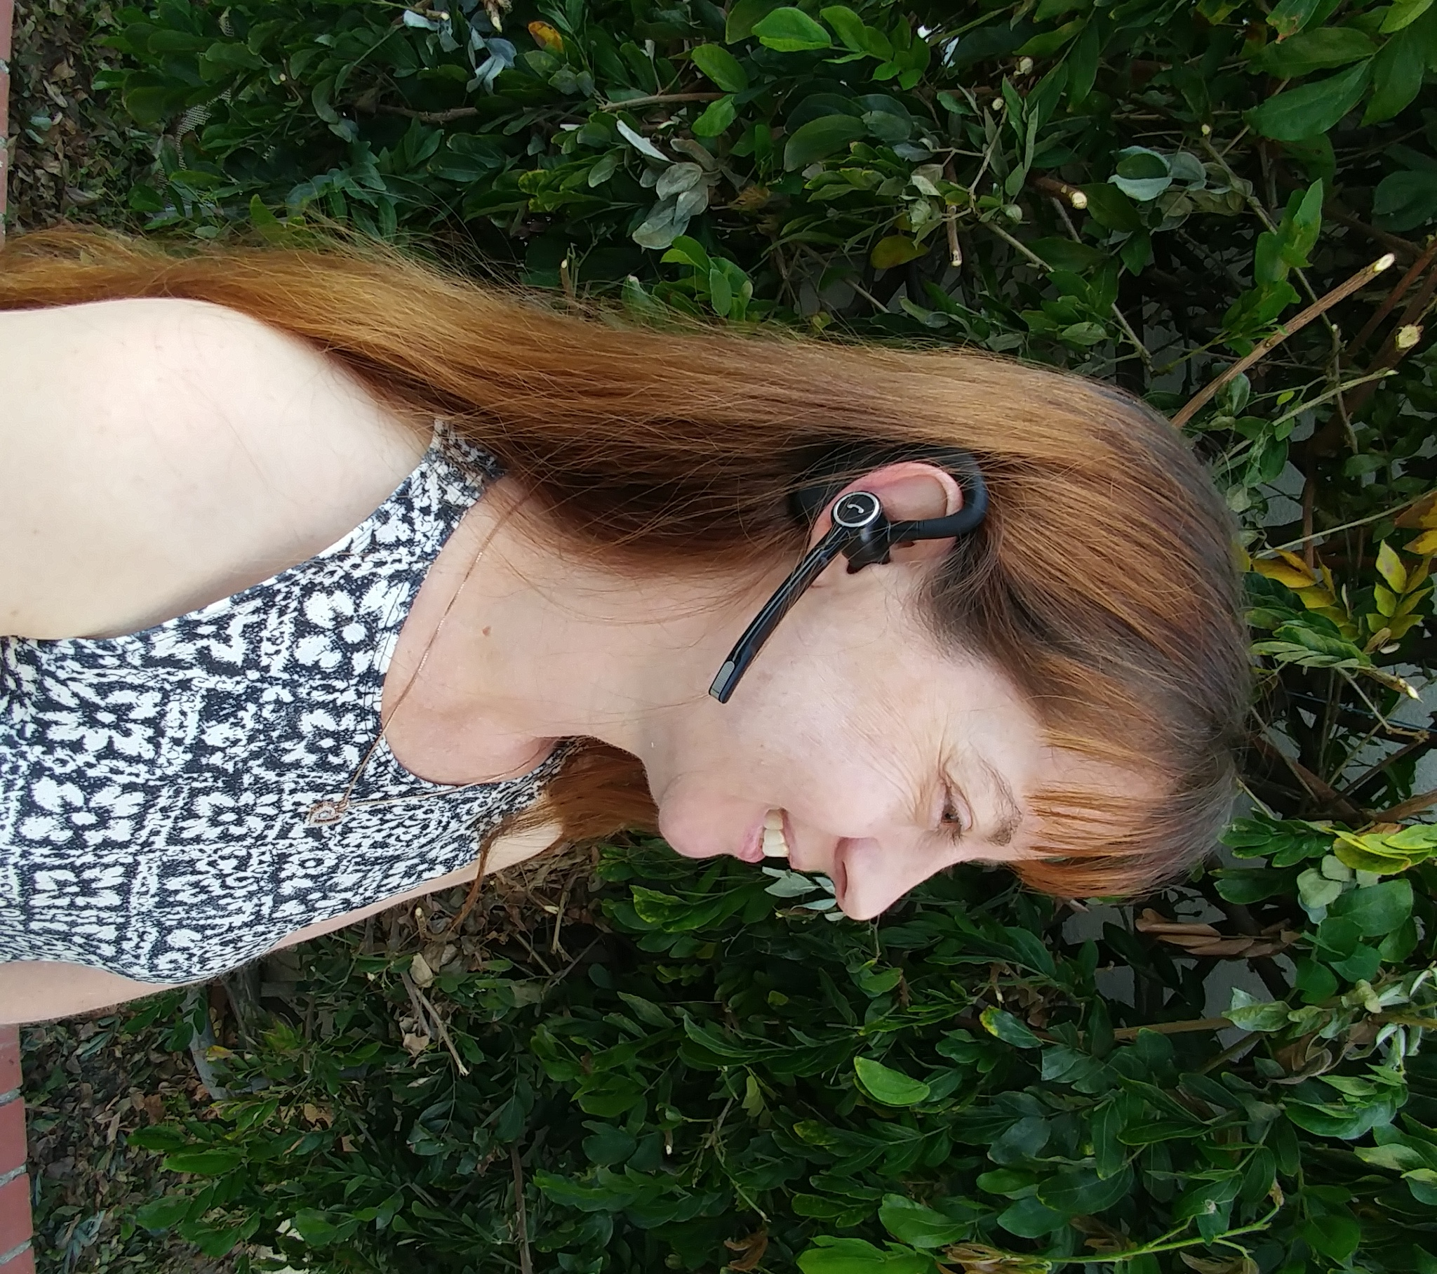
PUSH TO TALK BUTTON

TAP THE SIDE BUTTON ON THE EARPIECE TO START/ END IN “ONE TOUCH” MODE OR PTT

NOTE THAT THE RADIO MUST HAVE BLUETOOTH ENABLED AND THE SELECTION OF PTT METHOD SET UP IN THE PROGRAM TO MAKE THE UNIT WORK CORRECTLY.

ENTERPRISE ELECTRONICS 22826 MARIPOSA AVE. TORRANCE CA 90502 310.534.4456

SEE THE NEXT PAGE FOR A SAMPLE PROGRAM SCREEN FOR F52/62 RADIO
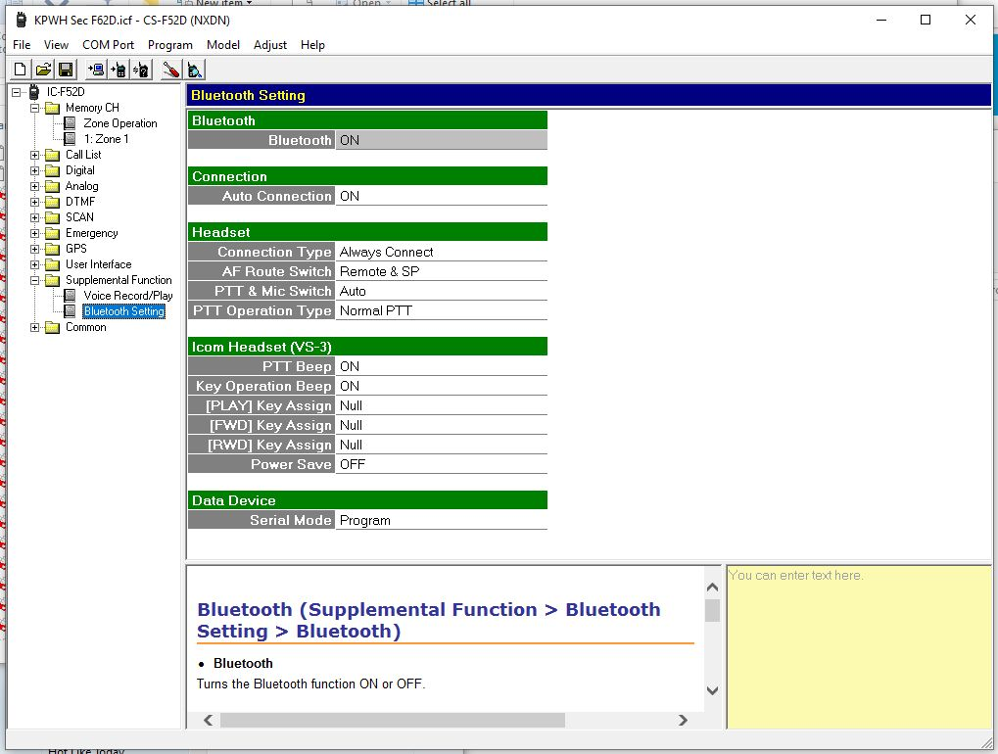

FOR THE IP501 H or M IP Radios

- Turn the radio OFF and make sure the BT is charged and turned OFF to begin
- On the IP501H enter the Set Mode by powering up the radio WHILE pressing and holding the FUNC key for approximately8 seconds until you hear a beeping sound and the screen is pulsing & scrolling, release it and;
- The Display will show Set in the upper left corner
- Press the Address Book key repeatedly until the Display shows Bluetooth
- Press the up/down keys and verify the Display shows Enable
- Turn on the BT earpiece now by pressing and holding the ON switch until it wakes up in Pairing Mode by rapidly flashing the LED red/blue/red/blue so now MOVE FAST:
- Press the Call History key (lower left key) on the radio; it will display Searching and it will take around 10 seconds to find the ICOM BT unit and lock onto it
- Last: press the CLR key once and wait; the display will clear and the radio will boot up & show the BT icon near the center of the radio; test by pressing the PTT button on the BT earpiece and you are talking

After turning both of them off, recharging the earpiece & radio and the NEXT time you go to use them:

- Power up the IP501 radio and wait until it is booted up, the BT icon will not be displayed; THEN
- Power up the BT earpiece by holding the switch for 2-3 seconds (not necessary to go to Pair Mode) and
- The LED will flash a few times and then light up solid BLUE and the radio will turn on the BT icon
- Now you are reconnected

